Kellogg School of Management Northwestern University
 Kellogg

SEEK 460: Values Based Leadership

Section 81

Winter 2007

Professor David Austen-Smith
Leverone Hall Room 530

Phone: 847-467-3496
E-mail: dasm@kellogg.northwestern.edu

TA: tba

CONTENTS
Course Overview Page 2
Course Requirements Page 3
Class Schedule and Topics Page 5
Group Evaluation Form Page 15
Course at a Glance Page 16

Course Overview and Objectives

This course adds a unique perspective on leadership over and above the traditional focus on practical leadership and the normal levers of influence. Whereas practical leadership involves the creation of incentive systems that motivate productive and effective action by stakeholders, values-based leadership motivates stakeholders by example and by articulating principles and standards of behaviour. To lead others effectively you must anticipate how they will respond to values-based arguments and symbols, and how emotions drive attitudes and behaviour.

The course extends the typical focus on strategy to incorporate a wider perspective. The first issue that a values-based leader must address is the organization's “value proposition.” The standard strategy literature addresses this problem by a careful market analysis that looks at the monetary value to consumers of potential product mixes and then examines the organization’s competitive advantage relative to other organizations in providing those product mixes. Although a necessary first step in deciding whether to enter an industry or to begin a business undertaking, such analysis is incomplete as it does not address the wider impact of the organization's actions on its own employees and on society. This course focuses on the problem of incorporating a wide variety of value perspectives into decision-making.

Values-based leadership ultimately involves the ability to take the disparate value propositions of various stakeholders and integrate them into a coherent vision. Doing so requires the capacity to make tough choices, to take a stand and to offer an articulate and coherent justification for one's decisions. The course helps to develop this ability to consider a wide-range of value perspectives and to integrate them when making tough but importance decisions. It will provide self-insight and add intellectual depth.

During the course, we explore how recognizing and incorporating competing values claims throughout the organization is often facilitated and hindered by a number of psychological, organizational and cultural processes. Students will come to understand the variety of underlying mechanisms managers of organizations typically have at their disposal successfully to implement values objectives and select among different approaches, while anticipating the constraints placed on choice by the organization's market and non-market environments.

Course Format:
Each session, we will focus on various perspectives and challenges that are confronted in the ethical realm of organizational life. Our goal will be to give you the tools to effectively discern all the relevant value propositions in any given situation. We will accomplish this by discussing key theoretical concepts and analyzing related cases.

In each class session, we will use a case or exercise to motivate our discussion. You should come to class prepared to summarize key points from the day’s readings and to contribute to the case analysis. As you complete the readings, ask yourself:
- What is the basic argument the author makes?
- What are the key concepts/principles?
- So what? How does this matter for an organization?
- What are the implications for the kinds of challenges I may face as a leader?
- How can I apply this to my firm, my job, and my career?

This course reflects a dual focus on practice and conceptual training. The course packet articles introduce key concepts and useful ways of thinking about complex situations in organizations. Case studies and class exercises provide opportunities to apply theories, concepts, and research findings to particular situations and to hone your skills in defining ethical dilemmas and constructing appropriate solutions. The written assignments ask you to consolidate your insights and apply your own conceptualization of values based leadership.

Course Requirements and Assignments

Assignments:
Your final grade is composed of:
- Course Contribution 10%
- Individual Reflection Papers 25%
- Group Project: Organizational Blueprint 15%
- Final Group Project: Food Aid Stakeholder Analysis 25%
- Final Exam 25%

Course Contribution (10%)
All class sessions involve active discussion based on the readings and cases, with an emphasis both on theoretical questions and practical implications. You should be prepared to share your ideas and listen to and interpret the issues presented by others.

Please carefully review the readings and case for every class session. Most participation will be voluntary; however, in order to ensure that everyone has the opportunity to be involved, individuals will occasionally be called upon “cold.”

Quality discussion comments possess one or more of the following attributes:
- Offer a relevant perspective on the issue
- Provide careful analysis
- Apply the theory and concepts offered in the readings and lectures
- Move the discussion forward by building on previous contributions with new insights; do not repeat points already made by others
- May include asking good questions. This is a skill to be practiced as well; good questions are rarer than good answers.

Regular participation in discussions and class exercises is expected. If you must miss a class, it is essential that you notify me at least 24 hours in advance so that I can make arrangements for any in-class exercises and so that you can be certain to get the materials that will be distributed during the class.

Reflection Papers (25%)
On a number of occasions you will be asked to write a reflection paper. The purpose of the reflection papers is to encourage you to reflect on your past behavior and experiences in which value and ethical considerations were brought to bear so that you will have greater perspective in the future. There will be six individual reflection papers due every week, except weeks 1, 6, 9 & 10, by 1:30PM ON THE DAY OF THE CLASS.

Group Projects
You will be assigned to a Study Group for this course in the second or third week. You will work with this Study Group on your final group project and 2 other group assignments in which you will be required to construct and defend a particular value proposition or perspective. Theses two group assignments will be due in weeks 9 & 10.

Group Evaluations: You will have the opportunity to evaluate the preparation and work completed by your Study Group teammates. See the evaluation form in this syllabus for the specific criteria on which you will evaluate each other. These evaluations will be factored into your course contribution grade.

Organizational Blueprint (15%)
Your group will create an organizational blueprint for a start-up company (the specific type of company will be given in class). This assignment will include constructing a values/mission statement, a code of ethics, and an implementation plan for these statements. In doing so, you will need to take into account the culture to be created, the formal mechanisms to be instituted, and the values of various stakeholders to be considered. Be cognizant of the challenges and obstacles that your company may face in implementing its vision. Your organizational blueprint should produce a successful company and you will need to define what success means for your company.

The project should be 4-5 pages. A quality product should reflect the full panoply of course concepts. I am looking for you to go beyond simply outlining “what” to implement; your blueprint should address “why and how” you would execute the specifics of your blueprint - go beyond description to analysis. You will not be graded on the value perspectives you take, but rather on the congruence between the values you espouse and the organizational blueprint you construct.

Final Group Project: Food Aid Stakeholder Analysis (25%)
The final group project will be based on a Wall Street Journal article describing the controversy over the Bush Administration’s proposal to change the way food aid is distributed. Each group will be assigned a stakeholder in the food aid debate. Groups will then analyze the value propositions of all the key stakeholders in the case with a focus on their particular stakeholder organization. Subsequently, groups will be required to write a strategy memo and make two presentations.

The final presentation will occur in the final class of the quarter. The strategy memo will also be due on that date. As a part of the group assignment, you will be asked to evaluate the performance of all of the members of your group, including yourself. The evaluation form is included in the syllabus. More information about this group project will be provided in class.

Final Exam (25%)
The exam will be a take home exam that will be due via e-mail at 5pm on Monday March 12th. It will test your knowledge and understanding of all the relevant concepts explored in the class.

Office Hours:
I will be available to meet with you in my office (Leverone 530) before class between 5:00p-5:50p. If you would like to make an appointment to see me at another time, please contact me.

Consideration for Classmates:
A class requires careful attention to fairness and mutual respect for one another. You are expected to attend every class on time and to stay for the entire class session. If you have an unavoidable conflict, please do not disturb your classmates by arriving late, leaving early, or asking to have information you missed repeated during the class. Always let me know at least 24 hours in advance if you will miss a class session so that I can make arrangements for any in-class exercises to be certain that your classmates do not suffer from your absence. This advance notice will also allow us to make arrangements to ensure that you get all of the materials distributed in that class.

If you are familiar with a case or an exercise introduced in class, please do not discuss your prior knowledge with other students, as this can ruin the learning experience for them. Telling other students (in any section) about your experience with cases and exercises is an honour code violation. If you are concerned that your prior experience with a case might be an issue, please let me know before class.

This course adheres to the guidelines established in the Kellogg Honor Code and the Kellogg Code of Classroom Etiquette.

Varieties of Ethical and Market Perspectives
January 9
Class 1

Objectives:
- Perspectives on what corporations are supposed to do
- The role of leaders in creating value propositions

Read:
- Friedman: The Social Responsibility of Business is to Increase its Profits
- Arrow: Social Responsibility and Economic Efficiency
- Friedman/Mackey debate

Case:
- To be handed out in class.

Discussion Questions:
- What social goals can market competition promote?
- Do you agree with Friedman that corporate managers have a moral imperative to maximize stockholder value?
- What are the principle economic reasons that might undermine Friedman’s position? Do you find these reasons compelling?

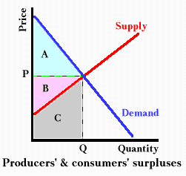

Foundations of Public Reason
January 12
Class 2

Objectives:
- Navigating ethical dilemmas successfully
- Fundamental value propositions
- The paradox of behavioral forecasting and false consensus

Read:
- Machiavelli: The Prince
- Plato: The Republic
- Abraham Lincoln’s Letter to Horace Greeley
- Martin Luther King Jr.: Letter from Birmingham City Jail
- Kidder: The Ethics of Right versus Right, Justice versus Mercy
- David Baron: Utilitarianism

Discussion Questions:
- What do Lincoln, Machiavelli, King and Plato suggest are the primary obligations of a leader?
- When and why does King suggest leaders should obey the law?
- Based on your own experiences, how applicable are these views for leaders?

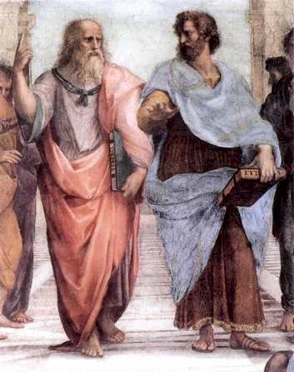

DUE: First Reflection Paper: Please write and bring to class, a short description (about 100 words) of a dilemma you faced at work between two or more conflicting value propositions (such conflicts are sometimes categorized as “ethical dilemmas”)..

“Tough Choices” Survey (to be completed before class)

Fairness and Rights
January 16
Class 3

(Please bring a laptop computer to this class)
Objectives:
- Distributional justice and schemas for "fair" allocation
- Understanding ethics as constraints rather than objectives
- [Preview final project]

Read:
- Feinberg: Distributive Justice
- Singer: Rich and Poor

Case:
- Handed out in class

Discussion Questions:
- Do individuals have an obligation to reduce poverty? Do corporations?
- How do group identities affect conceptions of distributive justice?

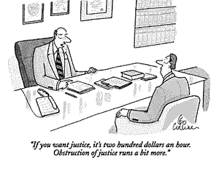

DUE: Second Reflection Paper: What standard of fairness do you most often apply in your professional life and in your everyday life? Are these standards ever in conflict?
The Impact of Emotion and Perspective on Decision-making
January 23
Class 4

Objectives:
- Examining the psychological roots of ethical behavior
- How psychological processes both contribute to and interfere with ethical behaviour and maximizing self-interest

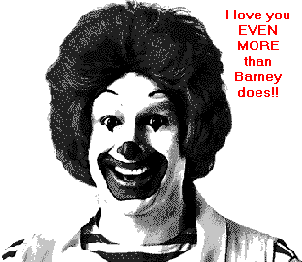
Read:
- Bazerman, Loewenstein, & Moore: Why Good Accountants Do Bad Audits
- Greene, Sommerville, Nystrom, Darley, & Cohen: An fMRI Investigation of Emotional Engagement in Moral Judgment
- Lerner: Negotiating Under the Influence; Effect of Anger on Detecting Interests

Case:
- McLibel Case

Discussion Questions:
- What, if any, difference is there between decision making based on emotions and decision making based on value propositions?
- When and what type of emotions lead to moral behavior and maximizing self-interest, and when do they blind people from their own best interests and the interests of others?



DUE: Third Reflection Paper: To what extent have you found that yours and others’ business decisions been driven by emotion? How do you think emotions affect the type of reasons people give to justify their decisions?

Stereotyping and Discrimination
January 30
Class 5

(Please bring a laptop computer to this class)
Objective:
- Privilege versus discrimination and the role of stereotyping
- Whether rights-based ethical systems elevate the individual over the collective or aggregate
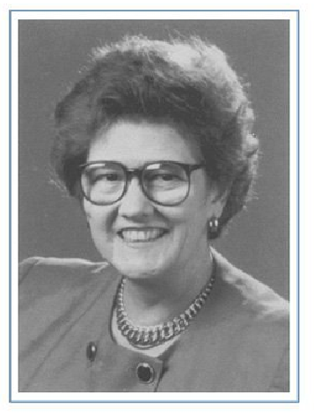

Read:
- Banaji, Bazerman, & Chugh: How (Un)ethical Are You?

Case:
- Anne Hopkins

Discussion Questions:
  - What do you think contributed to the way Anne Hopkins was treated? What could Price Waterhouse have done differently?
  - What approach could organizations use to manage diversity?

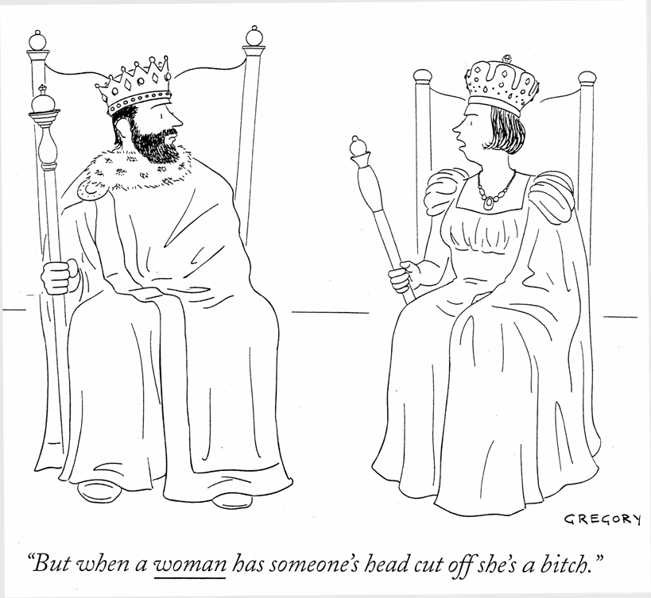

DUE: Fourth Reflection Paper: Write a one page analysis of an experience you have had with stereotyping, prejudice or discrimination. You could have witnessed the discriminatory behavior, been the target, or inadvertently stereotyped or discriminated against someone else.

Integrating Moral and Market Sentiments
February 6
Class 6

Objectives:
- Bounded personal ethics and how the process of defending one's ethical position can create problems
- Impact of one's background (engineering, etc.) on value perspectives

Case:
- Genzyme (to be distributed via email in Week 5)

Discussion Questions:
- Should Ceredase be manufactured at all? If so, how would you price it?



DUE: Genzyme Case Project: You will be required to take the position of one member of the Genzyme management team (e.g. CFO, legal, technology etc.). You will be responsible for developing a one page memo to use in a cross-functional meeting in which Genzyme has to decide whether to produce Ceredase, and if so, how to price it. You will receive more details prior to class.

Values-Based Marketing: Propaganda, Marketing to the Vulnerable, and the Virtuous Consumer
February 13
Class 7

Objectives:
- Understanding the difference between values-based marketing and pure propaganda
- Marketing to the vulnerable—a predatory practice or savvy strategy?
- How to target the right virtues in the right consumer

Read:
- Pratkanis and Aronson: Age of Propaganda pp.48-67
- Brenkert: Marketing To Inner-City Blacks: Powermaster and Moral Responsibility

Discussion Questions:
- What is the difference between exploitation and expertise in marketing?
- How does stereotyping influence the way that companies market to vulnerable consumers? When is target marketing wrong?

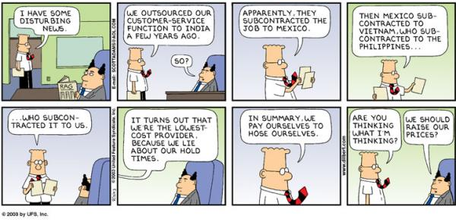

DUE: Fifth reflection paper. Find an advertisement for (A) a product whose main purpose conflicts with a strong value you hold, and (B) a product whose main purpose supports a strong value you hold. Write a one page reflection paper identifying the values expressed in each ad and the consumers being targeted. Comment on how the values embodied in the product affect the type of advertisement being used.

What's to Be Done? Managing Values through Incentives and
Informal Mechanisms
February 20
Class 8

Objectives:
- How to induce ethical behavior through incentives
- Understanding the perverse effects of incentives, sanctioning systems, and contracts
- Considering structural and cultural mechanisms for managing values
- Creating corporate value statements and understanding the meaning of values

Read:
- Kidder: Core Values
- Kinni: Words to Work By: Crafting Meaningful Corporate Ethics Statements

Case: Veridian

Discussion Questions:
- Given the processes inherent to conflicts of interests (and that warnings seem to be ineffective), what remedies would you propose to deal with this vexing problem? Think of one way to eliminate the self-serving biases that spring from many incentive plans.
- After a company creates a value statement, how might the company encourage employees to adopt its ideals?
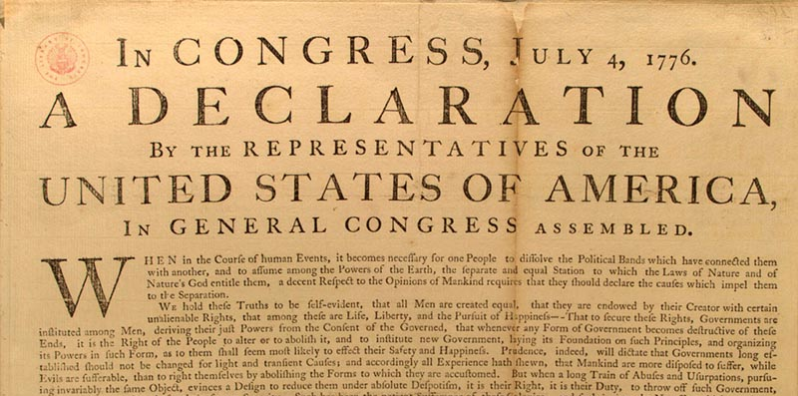

DUE: Sixth Reflection Paper: Identify any limitations of the Kellogg honour code. Suggest a revision to the honor code to support values-based behavior.

Global Environment of Ethics and Business and the Role of
Corporate Social Responsibility

February 27

Class 9

Objectives:
- Exploring how laws, norms and expectations serve as socio-cultural and institutional bases of ethical judgment
- Integrating historically conditioned ethical standards
- How globalization and culture affect the relativism of values

Read:
- Donaldson: Values in Tension: Ethics Away from Home
- Vogel: Is there a Business Case for Virtue?

Case:
- Unocal Pipeline case

Discussion Questions:
- Suppose that the CEO of Unocal decides to do the gas pipeline project with the Burmese government. Who are the critical stakeholder groups and what should the CEO tell them?

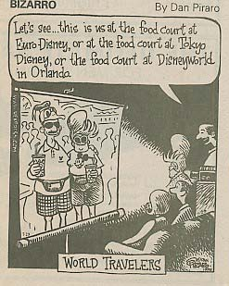
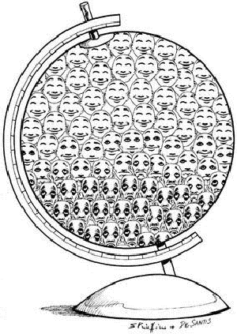

DUE: Group Project: Organizational Blueprint

Wrap up and Class Projects
March 6
Class 10

Objectives:
- Thinking clearly about value propositions that are in play
- Considerations for your career
- Bringing it all together

Read:
- Badaracco, Jr.: The Discipline of Building Character

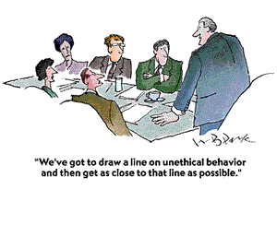
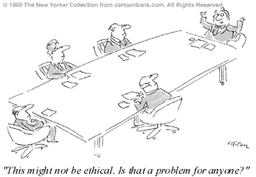

DUE: Group Presentations and Strategy Memo

Group Evaluation
Please use this form to evaluate all of the members of your group, including yourself, on your work together analyzing the cases and preparing presentations and memos. Grade each group member using the comparative scale below. Awarding a teammate a “1” would indicate that his or her initiative, dependability, etc. went above and beyond that of the other team members. In contrast, a “-1” would reflect efforts that they weren’t up to par with the other teammates’ inputs – that the person could have done more to carry a fair portion of the workload. A zero would indicate that the team member’s efforts and contributions were equal to that of most of the other group members.

[-1]……[-0.5]……[0]…...[0.5]...…[1]
Could have done more equal exceptional contributions

Team Member Name | Quality of Contribution | Dependability | Initiative

Additional comments (if necessary)

COURSE SCHEDULE

Date | Topic | Before Class - To Read | In Class Case | After Class - To Do | Assignments Due Today
Class 1 | Introduction; Varieties of Ethical and Market Perspectives | Friedman: The Social Responsibility of Business is to Increase its Profits  Arrow: Social Responsibility and Economic Efficiency  Friedman/ Mackey debate: | Case to be handed out in class | Read short essays for Class 2 and write the First Reflection Paper
Class 2 | Foundations of ethics | Machiavelli: The Prince  Abraham Lincoln's Letter to Horace Greeley  Plato: The Republic  Martin Luther King Jr.: Letter from Birmingham City Jail  Kidder: The Ethics of Right versus Right, Justice versus Mercy  David Baron: Utilitarianism |  | Second reflection paper | First Reflection Paper  "Tough Choices" Survey
Class 3 | Fairness and Rights | Singer: Rich and Poor  Feinberg: Distributive Justice | Kidney Transplant  (Please bring a laptop computer) | Third reflection paper | Second Reflection Paper
Class 4 | The Impact of Emotion and Perspective on Decision-making | Messick & Bazerman: Ethical Leadership and the Psychology of Decision Making  Greene, Sommerville, Nystrom, Darley, &Cohen: An fMRI Investigation of Emotional Engagement in Moral Judgment  Lerner: Negotiating Under the Influence; Effect of Anger on Detecting Interests | McLibel | Fourth reflection paper | Third Reflection Paper

Date | Topic | Before Class - To Read | In Class | After Class - To Do | Assignments Due Today
Class 5 | Stereotyping and discrimination | Banaji, Bazerman, & Chugh: How (Un)ethical Are You? | Anne Hopkins  (Please bring a laptop computer) | Genzyme project & presentation | Fourth reflection paper
Class 6 | Integrating moral and market sentiments | Genzyme | Genzyme | Fifth reflection paper | Genzyme case group project
Class 7 | Values based marketing | Pratkanis and Aronson: Age of Propaganda pp.48-67  Brenkert: Marketing To Inner-City Blacks: Powermaster and Moral Responsibility | To be announced | Sixth reflection paper | Fifth reflection paper
Class 8 | Managing values and incentives | Kidder: Core Values  Kinni: Words to Work By: Crafting Meaningful Corporate Ethics Statements | Veridian | Group project: Organizational blueprint | Sixth reflection paper
Class 9 | Global environment of ethics | Donaldson: Values in Tension: Ethics Away from Home  Vogel: Is there a Business Case for Virtue? | Gas-Pipeline case | Final preparations for Final group project | Organizational Blueprint
Class 10 | Overview and conclusions | Badaracco, Jr.: The Discipline of Building Character |  |  | Group Presentations: Final project
 | Final Exam |  |  |  | Final exam

